May 21, 2024

**Online Activity**

1. Display the list of all course sections offered in Spring 2018, along with the ID and name of each instructor teaching the section. If a section has more than one instructor, that section should appear as many times in the result as it has instructors. If a section does not have any instructor, use null.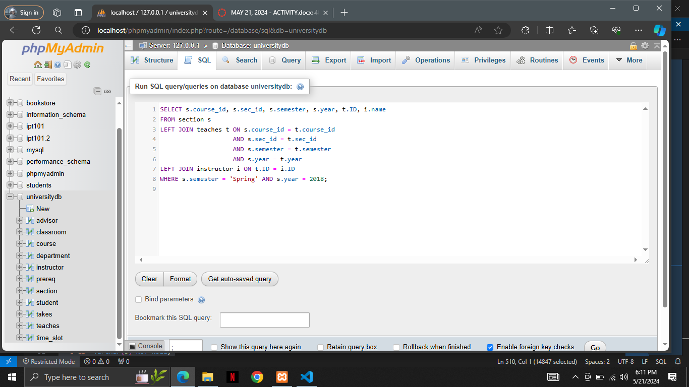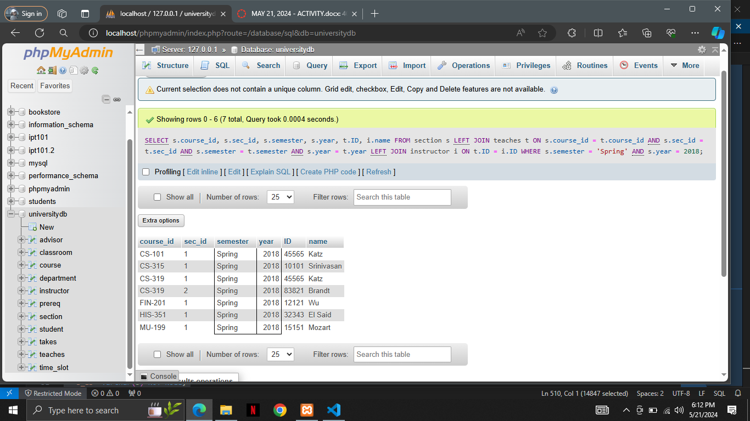

*Place the screenshot of your query and the result relation below.*

1. Write an SQL query using the university schema to find the ID of each student who has never taken a course at the university. Do this using no subqueries and no set operations (use an outer join).

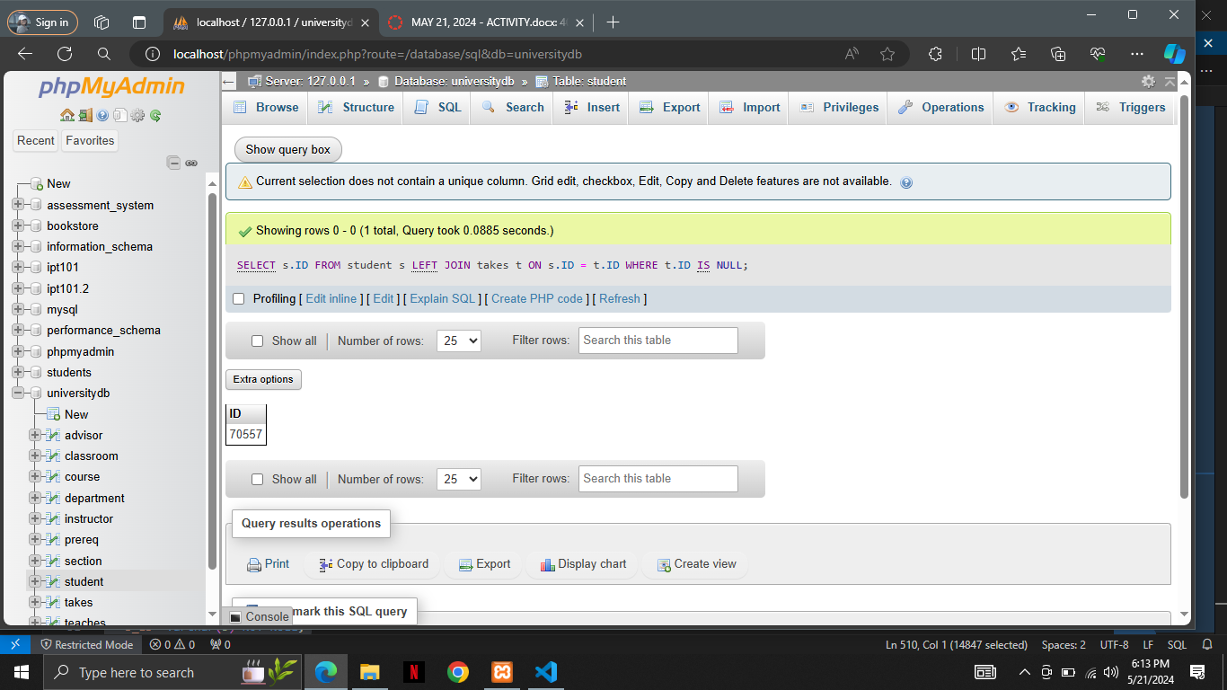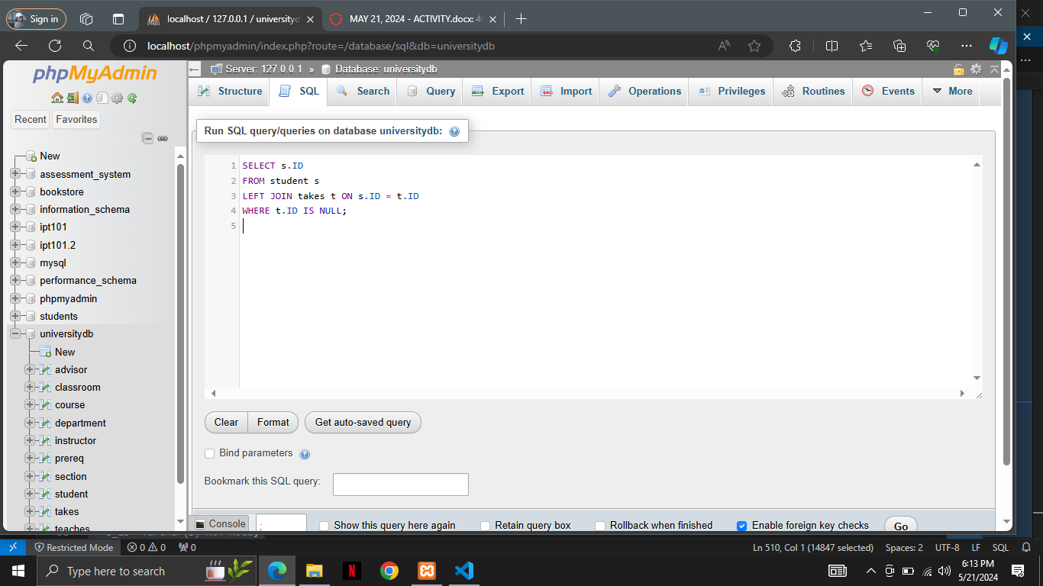

*Place the screenshot of your query and the result relation below*

1. Outer join expressions can be computed in SQL without using the SQL outer join operation. To illustrate this fact, show how to rewrite each of the following SQL queries without using the outer join expression.
   1. select * from student natural left outer join takes 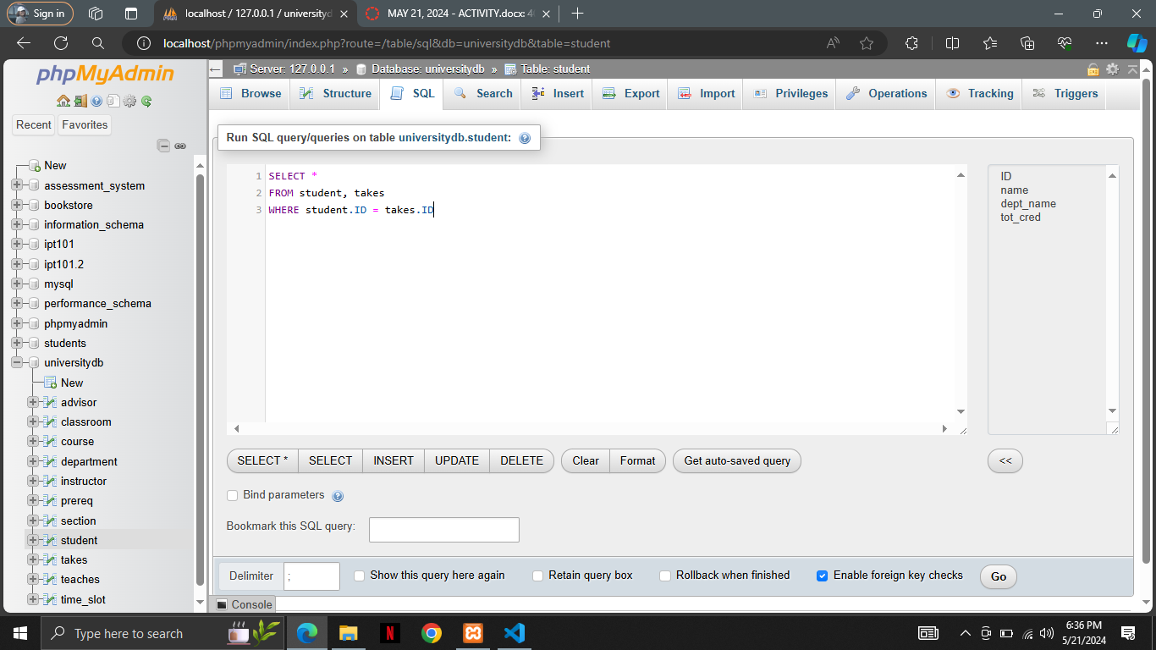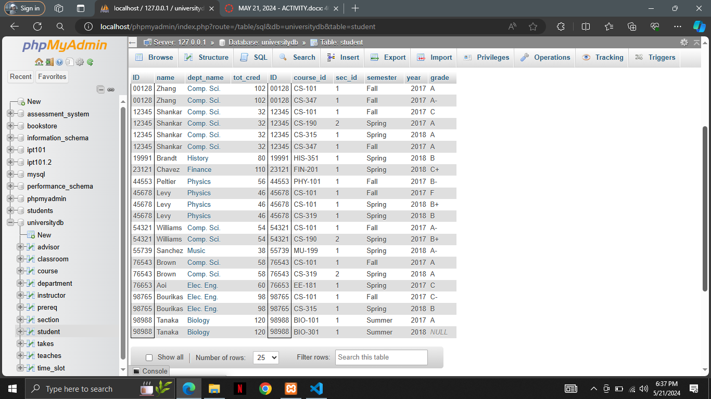
   2. select * from student natural full outer join takes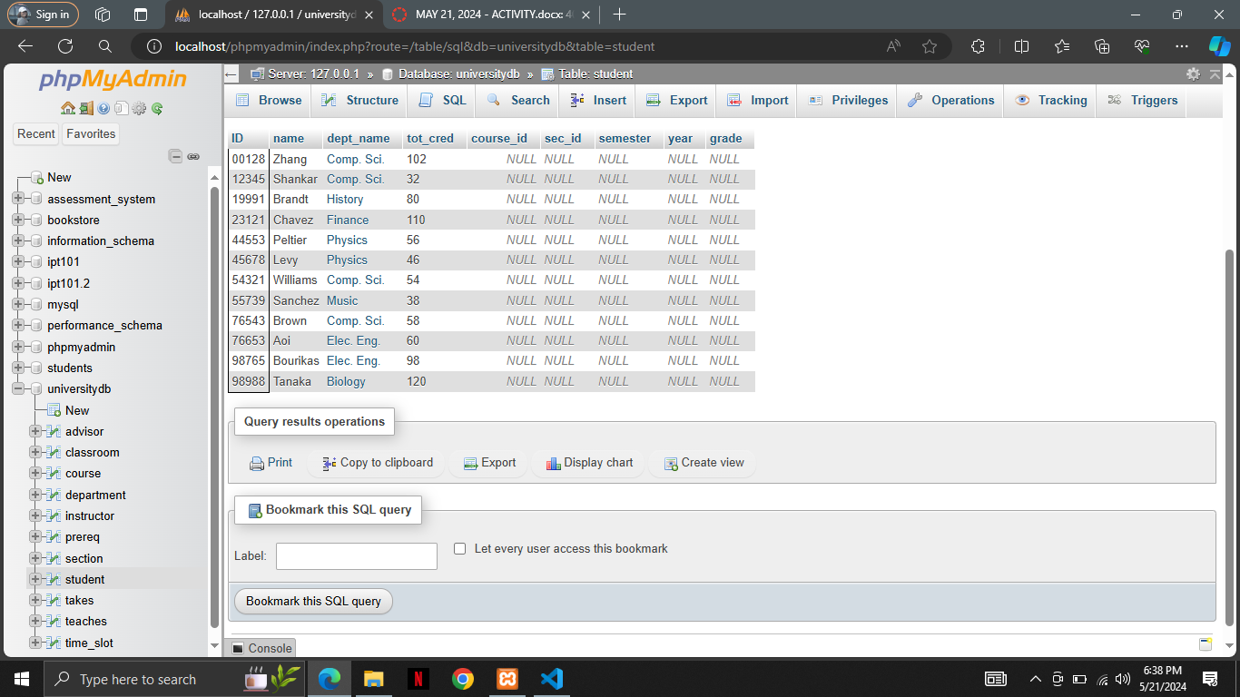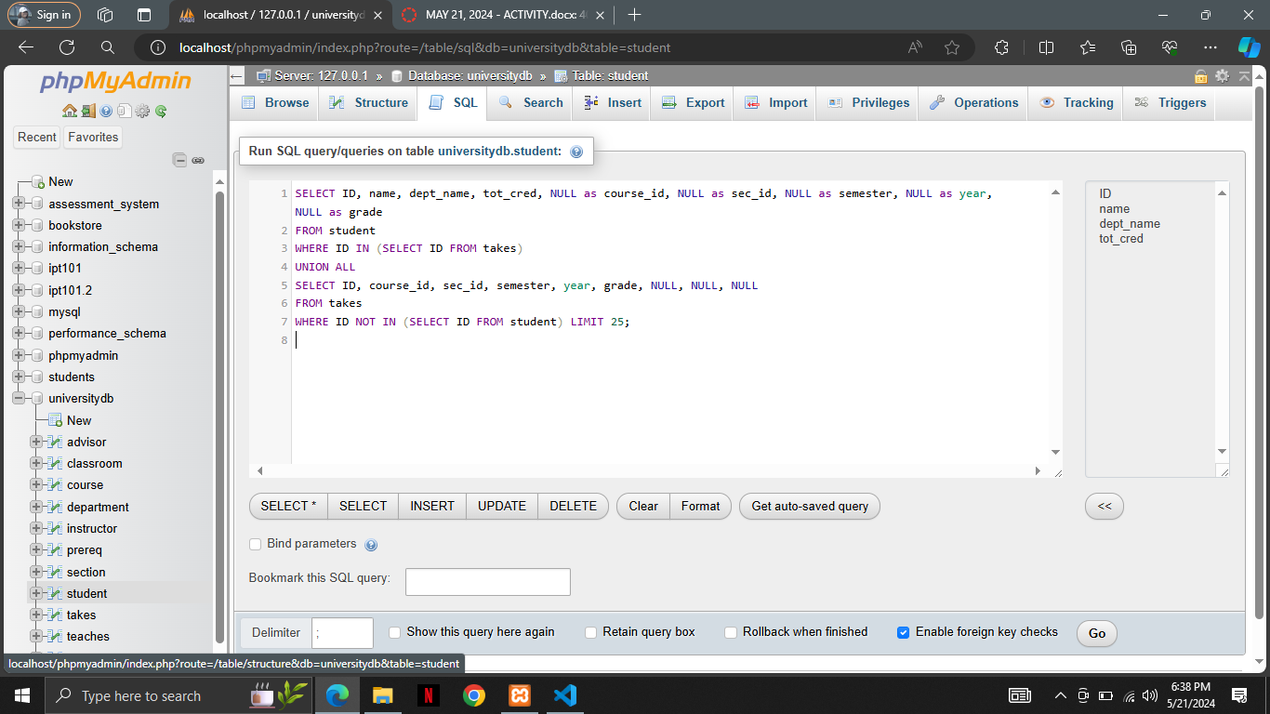

*Place the screenshot of your query and the result relation below*